10.9.2017

**Reinstate the HK live monitor**

Purpose:

Keep abreast of what’s happening in the HK market.

Follow important stocks only. Ignore smaller 老千股。

Keep track of AH spread, use it as a sentiment indicator. (A50 does follow H)

Note the limit of 100 per sec. Use semaphore.

1. Monitor mostly the high sharpe stocks
2. From 9:20 data starts to flow in (from IB)
3. Keep 1 day data in hibernate (for now, going forward might add 2 days)
4. Aim at about 500 stocks first. (HK main list)

Requirements:

1. Live ah spreads (AH ticker)

Technical:

New classes: HKData, HKStock, HKSave

HK Data:

1. Get (from IB) (how to request? How to receive? (receive it HKData as a handler or a separate handler)
2. Save (retrieve from historical or save to hib)

Streamline the current data acquisition process.

1. reqID needs to be linked with a global object that specifies contract being requested and handler.
2. Map<ReqID, Request> ReqID is an integer, request is constructed by (contract, handler)
3. Instead of handler, could be (contract, dataconsumer) which specifies the method with which to handle data which is returned from eclient method historicalData
4. Historical data can also be in the same framework.

Start with Request(contract, ITopMktDataHandler)

Problems:

1. Req ID generation is currently messy
2. Historical data and live market data not in the same framework.

Make sure HK live works first, then migrate XU later. Then migrate historical pricing.

**Weekend tasks in R**

Weekend tasks should include:

1. Trading recap (how did trading go?)
2. Brokerage (how much brokerage paid?)
3. ptf sharpe by day, aggregate AM and pm return, trading pnl.

**Optionality watch**

1. vol surface monitor
2. short dated vol term structure
3. arbitrage opportunities

**US Overnight trading:**

1. Interested stocks – accumulate if satisfies a drop threshold
2. Build up Overnight US monitor.

**Migration to IntelliJ**

* Netbeans is very buggy
* size is weird
* up/down arrow doesn’t scroll screen
* set up hibernate

(Update this has started, database is set up as of 10.12, startDB bat is in place)

(10.16 migrated to intellij, everything functional)

Market:

A50 kept trading at premium for pretty much last week, someone might have leaked the news.

Set up live AH spread.

View AH only. Or view HK only. AH list needs to be present in trading folder.

Learn intellij

jdbc:derby://localhost:1527/sample

jdbc:derby://C:/Derby/sample

Persistence :

<?xml version="1.0" encoding="UTF-8"?>

<persistence version="2.1" xmlns="http://xmlns.jcp.org/xml/ns/persistence" xmlns:xsi="http://www.w3.org/2001/XMLSchema-instance" xsi:schemaLocation="http://xmlns.jcp.org/xml/ns/persistence http://xmlns.jcp.org/xml/ns/persistence/persistence_2_1.xsd">

<persistence-unit name="JavaApplication3PU" transaction-type="RESOURCE_LOCAL">

<provider>org.eclipse.persistence.jpa.PersistenceProvider</provider>

<properties>

<property name="javax.persistence.jdbc.url" value="jdbc:derby://localhost:1527/sample"/>

<property name="javax.persistence.jdbc.user" value="app"/>

<property name="javax.persistence.jdbc.driver" value="org.apache.derby.jdbc.ClientDriver"/>

<property name="javax.persistence.jdbc.password" value="app"/>

<property name="javax.persistence.schema-generation.database.action" value="create"/>

</properties>

</persistence-unit>

</persistence>

**2017.10.11**

Database:

Netbeans is very buggy ( cannot scroll with arrow key)

Migration to intellij has started.

Database issue:

2 ways to connect, they are **mutually exclusive.** Meaning that access with one of them will prevent access with the other.

**Connection with embeddeddriver to the local database.**

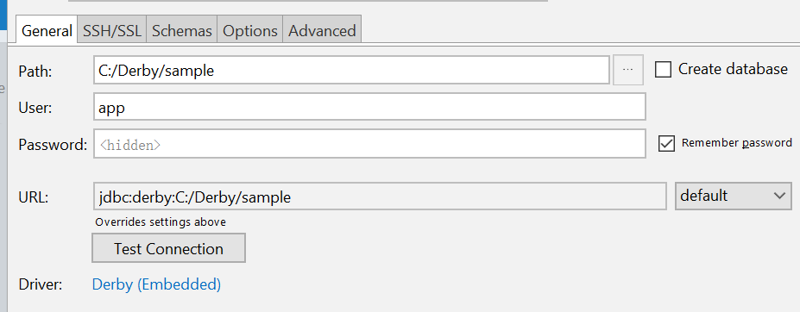

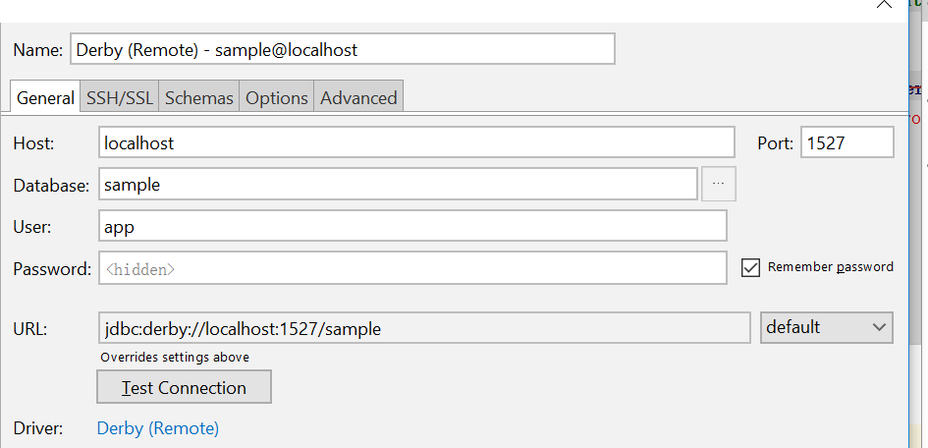

Currently the local access flavor is preferred because remote access requires netbeans to open the DB. Network server start is currently not working for the purpose of starting the DB. Even if it worked, it would be an extra step compared with local access.

Find out how to start network server independently without netbeans so that Intellij can use DB. In the time being, just use local access.

It turns out after setting derby system home, you can connect to the DB.

Windows:

java **-Dderby.system.home=c:\Derby** -jar derbyrun.jar server start

Note that in linux console you must use double slashes.

java **-Dderby.system.home=c:\\Derby** -jar derbyrun.jar server start

Bat files were written to facilitate the database connection process.

**Need to do weekly A share updating methodology soon.**

Using ideavim in IntelliJ idea. Be good with VIM. (Not started with vim yet 10.16)

10.12.2017

Morning task improvements:

1. shcomp improvement (make that a part of morningtask)

Hk monitor:

US weekend monitor:

A share weekly updating:

10.13.2017

Overhaul the java project structure. Flatten it.

Structure the whole thing more fluently.

Now it is very confusing.

The project should be in different location than the source.

1. Decouple the current structure
2. Apidemo is way too big
3. Chinastockhelper is way too big , should break into 1. Computation that is universally applicable 2. Computation that is related to pricemapbar 3. Computation that relates to saving

Top contributors of total pnl needed. (added in graphPnl)

You need net pnl today (mtm + buy + sell)

10.14.2017

There is a connection issue now when I’m logged on with V, I cannot browse chinese websites. (Use hk 1 for VP|\|)

NoV should be used during the day when I need data for china.

Other processes should obtain data from TDX files.

Periodically write OHLC prices to hib.

When executing morningtask, can get from TDX or HIB (sina.js) is dead. (Currently I use TDX day data to get)

Weekly pnl:

This week’s pnl attribution.

MTM: 30k

Fut: 3k

长江电力： 5k (16%)

贵州茅台： 15k (50%)

工行： 3K

海康： 5k

凯乐科技： 2k

恒瑞医药： 1.6k

方大炭素：-3k

隆基股份： -0.6k

Trade: < 1k

10.15.2017

Need to have a global identifier for last trading day. (for data retrieval)

涨幅/换手率 is another indicator that can be considered.

Following list is 涨幅/换手率. 换手率 is a measure of risk. I want stable growth with very little shares changing hand. This means that existing shareholders are institutions and they are unwilling to sell.



海天味业 can be included. Very low turnover with good returns. (Value investing)

Moutai is what I hold.

Construct a table of industry references

1. 东方财富 industry

Standardize methodology to deal with stock change every week.